AIR POLLUTION PREDICTION USINGRANDOM FOREST ALGORITHM AND DECISION TREE ALGORITHM

Main project report submitted

For partial fulfilment for the award of the degree

**B.TECH IN**

**COMPUTER SCIENCE&ENGINEERING**

Submitted :

|  |  |  |  |  |  |  |  |  |  |
| --- | --- | --- | --- | --- | --- | --- | --- | --- | --- |
| |  |  | | --- | --- | | A.VINEELA  P.SIVATEJA  B.PRIYANKA  B.SAI GANESH  G. SASI PAVAN  J. VARMA | 319129510024 | |  | 319129510001 | |  | 319129510051 | |  | 319129510048 | | 319129510001  319129510032  319129510009  319129510008  319129510052 319129510021 |
|  |  |

Under the Esteemed Guidance of Dr.PRASADA RAO, Assoc Prof , Dept.of CSE, WISTM.



DEPARTMENT OF COMPUTER SCIENCE AND ENGINEERING WELLFARE INSITUTE OF SCIENCE TECHNOLOGY AND MANAGEMENT

Approved by AICTE,New Delhi & affiliated to Andhra University Pinagadi (V),pendhurthi(M), Visakhapatanam-531173

### WELLFARE INSTITUTE OF SCIENCE TECHNOLOGY AND MANAGEMENT

Approved by AICTE,New Delhi & affiliated to Andhra University Pinagadi (V),pendhurthi(M), Visakhapatanam-531173



CERTIFICATE

|  |  |  |
| --- | --- | --- |
| This is to certify that the main project report entitled “AIR POLLUTION PREDICTION USING RANDOM FOREST AND DECISION TREE ALGORITHMS  submitted by | ” |  |
| A.VINEELA | 319129510001 |  |
| P.SIVATEJA | 319129510032 |  |
| B. PRIYANKA | 319129510009 |  |
| B.SAI GANESH  G.SASI PAVAN | 319129510008  319129510052 |  |
| J.VARMA | 319129510021 |  |

For partial fulfilments for the award of the degree Bachelor of Technology in Computer science and Engineering is a bonafide project work carried out by him .This work is not submitted to any University for the award of any degree.

**INTERNAL GUIDE HEAD OF THE DEPARTMENT**

**Dr.PRASADA RAO Mrs. N.SUNITHA(Ph.D)**

**ASSOC.PROFESSOR ASSISTANT PROFESSOR**

**DEPARTMENT OF CSE, DEPARTMENT OF CSE**

**WISTM ENGG.COLLEGE WISTM ENGG.COLLEGE**

EXTERNAL EXAMINER

**ACKNOWLEDGEMENT**

The satisfaction that accompanies the successful completion of any task would be incomplete without the mention of people who made it possible and whose constant guidance and encouragement crown all the effort with success .I like to thank prof. M. James Stephen, Principal, of Wellfare institute of science, Technology and Management, for this kind cooperation that gives me boundless pleasure to avail this opportunity to express my deep sense of gratitude and whole hearted thanks to Head of Department **Mrs.N.SUNITHA Assistant Professor,** Department of computer science and Engineering and my project guide Dr.PRASADA RAO, **Assoc. Professor** ,Department of computer science and Engineering, and all the faculty of computer science department for their valuable suggestions and co-operation during the development of this project . I am really grateful to my parents and all my friends for their constructive suggestions to do this project in effective manner.

**DECLARATION**

I here declare that the project entitled “**AIR POLLUTION PREDICTION USING RANDOM FOREST AND DECISION TREE ALGORITHAMS**” has been done under the esteemed guidance of **Dr.PRASADA RAO, Assoc.professor**, Department of Computer Science and Engineering and is dissertation of my own work except where specifically ask to the contrary and is submitted to the department of Computer Science and Engineering, Wellfare Institute of science Technology and Management for the partial fulfilment of the requirement for the award of B.Tech degree.

A.VINEELA(319129510001) P.SIVATEJA319129510032) B.PRIYANKA(319129510009) B.SAI GANESH(319129510008) G.SASI PAVAN(319129510052)

J. VARMA (319129510021)

AIR POLLUTION PREDICTION PREDICTION USING RANDOM FOREST AND DECISION TREE ALGORITHMS

## 1.TABLE OF CONTENTS

**TITLE PAGE NO.**

1. ABSTRACT
2. LITERATURE SURVEY
3. INTRODUCTION
4. SYSTEM ANALYSIS
5. SYSTEM REQUIREMENTS
6. TECHNOLOGIES
7. CODING
8. SCREENS
9. CONCLUSION

# ABSTRACT

Due to human activities, industrialization and urbanization air is getting polluted. The major air pollutants involved are carbonmonoxide(co),Nitric oxide(NO),nitrogen dioxide(NO2),ozone(O3).

The concentration of air pollutants in ambient air is governed by the meteorological parameters such as atmospheric wind speed, wind direction, relative humidity, and temperature. In Earlier techniques such as probability, statistics etc. were used to predict the pollutants involved in air, but those methods are very complex to predict.so we are and going to use data mining techniques for the better approach to predict the airpollution and quality of air which are need to predict air, relative humidity by considering various parameters. such as CO,No2,No,temperature etc. So,to predict the pollution of air whether its increasing year by year or decreasing. We are going to use Decision tree and Random forest algorithms in Data mining techniques.

2.LITERATURE SURVEY

In this the author Pasupaleti et al. (2020) the decision tree, linear regression, random forest. Major air pollutants are taken and meterological condition are taken using Arduino Platform. Random forest gives better accurate result due to overfitting that reduces errors But drawback is Random forest uses more memory and high cost.

Haotian Jing & Yingchun Wang(2020) had predicted the air quality index using XG Boost.It uses the weak classifier and shortcoming of the previous weak classifier to form a strong classifier thus reducing the error between predicted and actual values .It uses the K- cross validation .The mean absolute error and coefficient of determination is determined to predict the difference between actual and predicted value. The drawback faced is that it takes the previous value and is affected by outlier unwanted pollutant in the air.

Desislava Ivanova and Angel Elenkov (2019) had used Raspberry Pi platform with Multilayer perceptron algorithm of machine learning to predict the air pollutant accurately. Multilayer perceptron overcome problem of classification which is used for discrete values and regression which is used for continuous value. In this author uses discrete values and had used multilayer perceptron using backpropagation and therefore input did not pass to the activation function resulting in 0 or 1indicating how big the difference between the predicted and actual value. The coefficient of determination(R2) obtained is better but more can be improved by increment feeding. In Elseviere 2018,The tittle is Forecasting air pollution load in Delhi using data analysis tools.The methods used are Time series regression.With limitations are Here we are using time series with regression.so again regression is limited to the linear relationship.It is easily affected by outliers.

Soubhik et al. (2018) had compared various algorithms like Linear regression, Neural network regression, Lasso regression, ElasticNet regression, Decision Forest, Extra trees, Boosted decision tree, XGBoost, KNN, and Ridge regression to predict air pollutant level.Better accuracy is obtained by extra trees because features are arranged in decreasing order of importance to predict the upcoming value.

# 3.INTRODUCTION

Air is a basic requirement for the survival and development of all lives on Earth. It affects health and influences the development of the economy. Today, due to the development of industrialization, the increase in the number of private cars, and the burning of fossil fuels, air quality is decreasing, with increasingly serious air pollution. There are many pollutants in the atmosphere, such as SO2, NO2, CO2, NO, CO. internationally, a large number of scholars have conducted research on air pollution and air quality forecasts, concentrating on the forecasting of contaminants. Air pollution affects the life of a society, and even endangers the survival of mankind. During the Industrial Revolution, there was a dramatic increase in coal use by factories and households and the smog caused significant morbidity and mortality, particularly when combined with stagnant atmospheric conditions. Humans are very sensitive to humidity, as the skin relies on the air to get rid of moisture. The process of sweating is your body's attempt to keep cool and maintain its current temperature. relies on the air to get rid of moisture. The processof sweating is your body's attempt to keepcool and maintain its current temperature. relies on the air to get rid of moisture. The processof sweating is your body's attempt to keepcool and maintain its current temperature.

If the air is at 100-percent relative humidity, sweat will not evaporate into the air. As a result, we feel much hotter than the actual temperature when the relative humidity is high. If the relative humidity is low, we can feel much cooler than the actual temperature because our sweat evaporates easily, cooling us off. For example, if the air temperature e is 75 degrees Fahrenheit (24 degrees Celsius) and the relative humidity is zero percent, the air temperature feels like 69 degrees Fahrenheit (21 C) to our bodies. If the air temperature is 75 degrees Fahrenheit (24 C) and the relative humidity is 100 percent, we feel like it’s 80 degrees (27 C) out. The study of mathematical optimization delivers methods, theory and application domains to the field of machine learningData mining is a field of study within machine learning, and focuses on exploratory data analysis through unsupervised learning. In its application across business problems, machine learning is also referred to as predictive analytics

# SYSTEM ANALYSIS

#### EXISTING SYSTEM:

In Earlier techniques such as Probability, Statistics etc. were used to predict the pollutants involved in air, but those methods are very complex to predict .sometimes the data is manuplated easily and data is not shown accurately .So we are going to use Data mining techniques and Decision tree , Random forest algorthims for the better approach to predict the airpollution .

* 1. **PROPOSED SYSTEM:**

The air pollution prediction using Data mining techniques considers two methods learning algorithms such as decision tree and Random forest algorithms. The Data mining techniques for the better approach to predict the airpollution and quality of air which the need to predict air, relative humidity . considering various parameters. such as CO,NO2, NO, Temperature etc. So,to predict the pollution of air whether its increasing year by year or decreasing.

.

# SYSTEM REQUIREMENTS

## HARDWARE REQUIREMENTS:

1. Processor – intel i3
2. RAM - 2GB
3. Hard disk - 500GB

## SOFTWARE REQUIREMENTS:

1. OPERATING System – Windows
2. Front end - CSS ,HTML ,JavaScript
3. Backend - Django,MYSQL.

**TECHNOLOGIES**

* DECESSION TREE ALGORITHM
* RANDOM FOREST ALGORITHM

DECISION TREE:

Decision Tree is one of the supervised learning algorithms which it is used to represent the decision that is made based on the condition. It is used for both classification and regression. The Decision tree is always constructed from top to bottom. The first node from the top is called as root node. The last nodes is called as a leaf node. Internal nodes are present in between the root node and leaf nodes. Based on some condition the internal nodes are split and finally, the decisions are made. In the real time as the number of variables increases tree grows larger and algorithm becomes complex. In Decision tree we have two types, they are classification and regression trees. Classification tree is used to classify the dataset. so that it is easy to analyze the data. But using this algorithm we cannot make a prediction. The Regression tree is a tree mainly used to predict continuous values.Growth of tree depends on factors like the attribute which is chosen to make a prediction,condition used for the split the tree; deciding when to stop or terminate the growth of the tree.

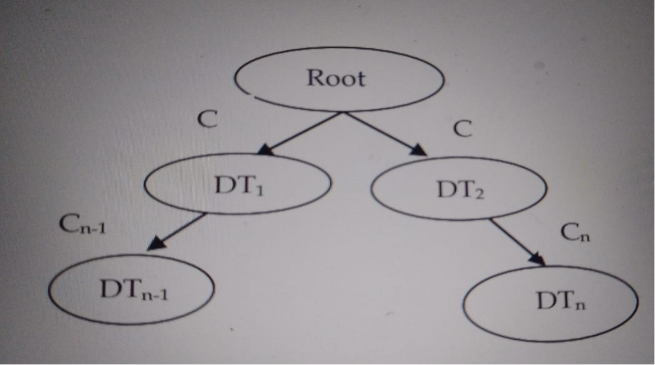

RANDOM FOREST ALGORITHM:-

It is defined as a set of decision trees to do regression and classification. Classification is used to find out the majority voting. Regression is used to calculate the mean value. This algorithm is more accurate, robust, and can handle a variety of data such as binary data, categorical data, and continuous data. Random Forest is nothing but multiple decision trees. 75% of the dataset is considered for the training. The training data is subjected to sampling and based on attribute sampling different decision trees are constructed by applying the Random Forest.

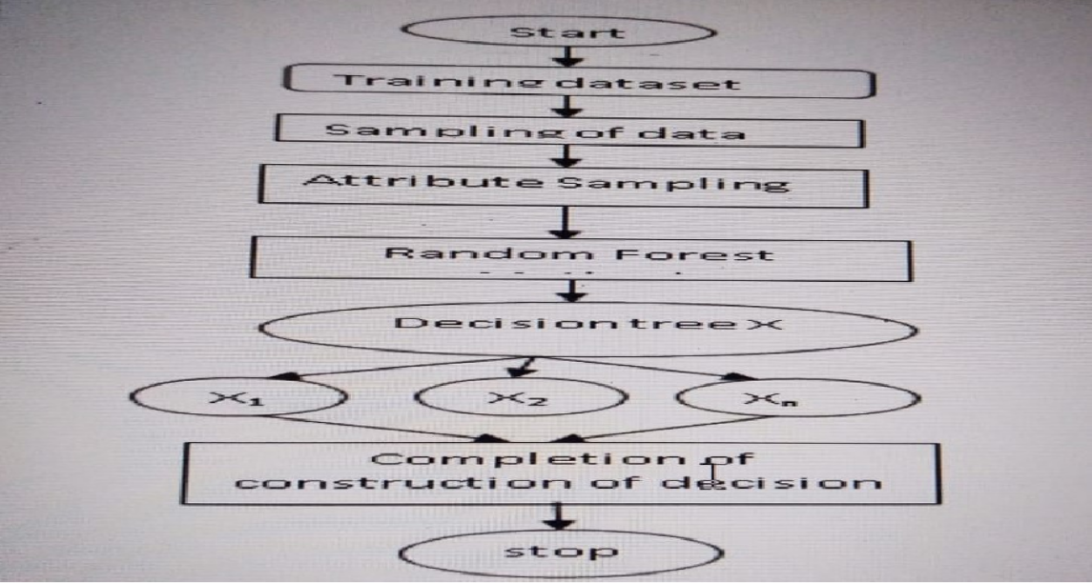

LITERATURE SURVEY:-

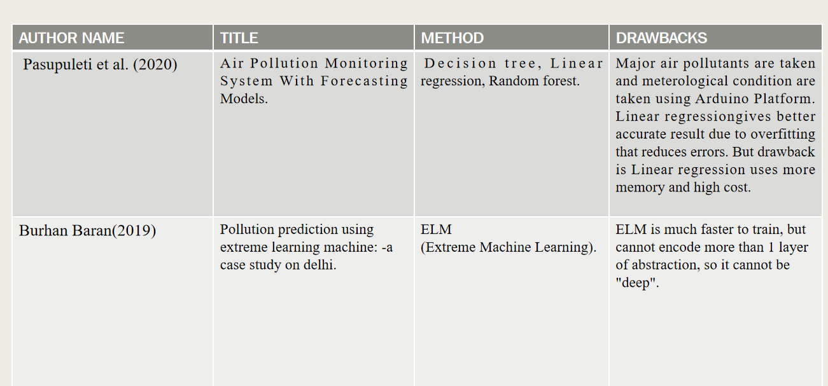

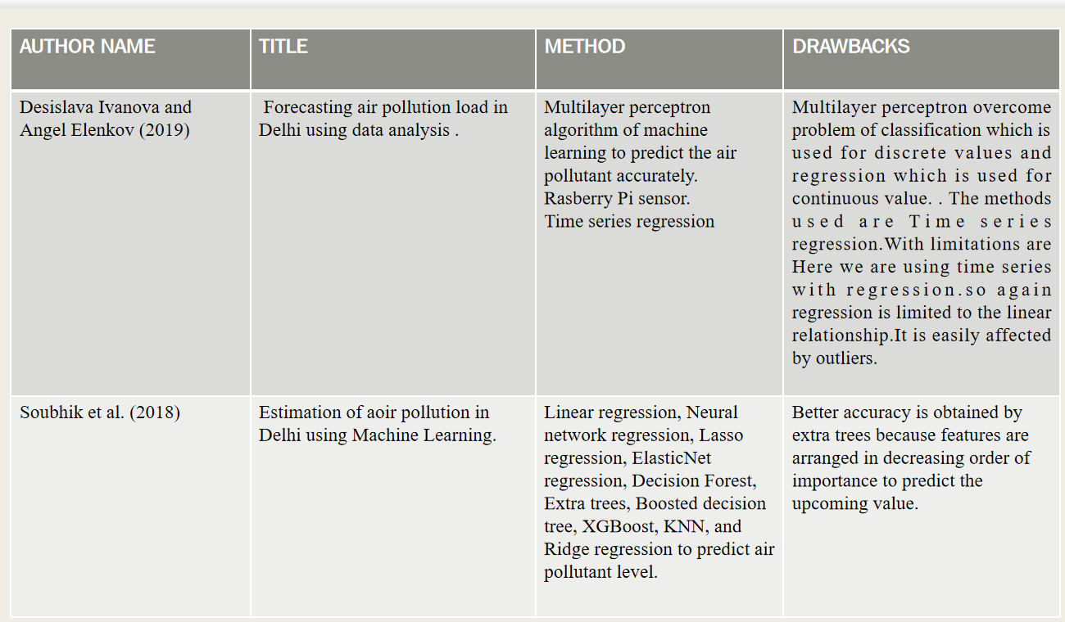

**INDEX.HTML**

# CODING

<!DOCTYPE html>

<html lang="en">

<head>

<meta charset="UTF-8">

<meta http-equiv="X-UA-Compatible" content="IE=edge">

<meta name="viewport" content="width=device-width, initial-scale=1.0">

<title>E-MARKET FOR FARMERS</title>

<link rel="stylesheet" href="f.css">

<link href="[https://cdn.jsdelivr.net/npm/bootstrap@5.1.3/dist/css/bootstrap.min.css](https://cdn.jsdelivr.net/npm/bootstrap%405.1.3/dist/css/bootstrap.min.css)" rel="stylesheet">

<!-- Latest compiled JavaScript -->

<script src="[https://cdn.jsdelivr.net/npm/bootstrap@5.1.3/dist/js/bootstrap.bundle.min.js](https://cdn.jsdelivr.net/npm/bootstrap%405.1.3/dist/js/bootstrap.bundle.min.js)"

></script>

</head>

<body>

<nav class="navbar ">

<div class="container-fluid">

<a class="navbar-brand" href="#">

<div class="nav-brand d-flex ">

<img src="./New folder/pngtree-agriculture-logo-template-farm-logo- template-png-image_5180811.svg" alt="" width="50" height="54" class="d-inline- block align-text-top">

<h3>E-MARKET FOR FARMERS</h3>

</div>

</a>

<div class="dropdown">

<button class="btn btn-secondary dropdown-toggle" type="button" id="dropdownMenuButton2" data-bs-toggle="dropdown" aria-expanded="false">

Language

</button>

<ul class="dropdown-menu dropdown-menu-light" aria- labelledby="dropdownMenuButton2">

<li><a class="dropdown-item active" href="#">English</a></li>

<li><a class="dropdown-item" href="#">Telugu</a></li>

</ul>

</div>

</div>

</nav>

<div class="bigcontainer">

<div class="bg-overlay"></div>

<div class="maincont">

<div class="getstarted">

<h2>Get started </h2>

<p>Farming needs within your hands.Join with us!</p>

</div>

<div class="emailcontain">

<h4><center>Enter Email id </center></h4>

<center><p>Email id: <input type="email" name="" id=""></p></center>

</div>

<center>

<a href="login.html" ><button onclick="" class="letsgo">Lets Go

</button></a>

</center>

</div>

</div>

</body>

</html>

## INDEX.CSS

*{

margin:0%; padding:0%;

box-sizing: border-box;

}

body,html {

overflow-x: hidden;

font-family: sans-serif; font-size: 16px;

}

.navbar

{

background-color: rgb(196, 244, 214); display:flex;

font-family: Georgia, 'Times New Roman', Times, serif;

}

.container-fluid a{ align-items: center;

}

.container-fluid img{ border-radius: 50%;

}

h3{

}

padding:10px;

.d-flex {

display: flex;

}

.nav-brand{

align-items: center; justify-content: center;

}

.bigcontainer{ background-image:

url('https://th.bing.com/th/id/OIP.ZE1_jfU1CLQGAtrwO0AbXgHaF7?pid=ImgDet&rs=1'); background-color: #cccccc;

background-position: center; background-repeat: no-repeat; background-size: cover; padding: 20px;

min-height: 80vh; display: flex;

justify-content: center; position: relative;

}

.maincont{

background-image: url('<http://csshint.com/wp-content/uploads/2020/01/CSS-> Animated-Backgrounds.gif');

margin:auto 80px ;

/* height: 33%; */ width: 500px; color: white;

border:white solid 5px; z-index: 2;

}

.getstarted{

color: white; padding: 30px;

}

input{

width: 280px; padding: 04px 12px;

}

.letsgo{

display: inline-block;

border-radius: 4px; background-color: #f4511e; border: none;

color: #FFFFFF; text-align: center; padding: 2px; width: 120px;

transition: all 0.5s; cursor: pointer; margin: 5px;

}

.bg-overlay {

position: absolute; top: 0;

left: 0;

width: 100%;

height: 100%;

background: rgba(1, 0, 12, 0.461);

}

button:hover{

box-shadow: 0 12px 16px 0 rgba(0,0,0,0.24), 0 17px 50px 0 rgba(0,0,0,0.19);

}

## LOGIN.HTML

<!DOCTYPE html>

<html lang="en">

<head>

<meta charset="UTF-8">

<meta http-equiv="X-UA-Compatible" content="IE=edge">

<meta name="viewport" content="width=device-width, initial-scale=1.0">

<link href=["https://cdn.jsdelivr.net/npm/bootstrap@5.1.3/dist/css/bootstrap.min.cs](https://cdn.jsdelivr.net/npm/bootstrap%405.1.3/dist/css/bootstrap.min.css)s" rel="stylesheet">

<!-- Latest compiled JavaScript -->

<script src=["https://cdn.jsdelivr.net/npm/bootstrap@5.1.3/dist/js/bootstrap.bundle.min](https://cdn.jsdelivr.net/npm/bootstrap%405.1.3/dist/js/bootstrap.bundle.min)

.js"></script>

<link rel="stylesheet" href="login.css">

<title>login form</title>

</head>

<body>

<div class="d-flex justify-content-center align-items-center container">

<div class="card py-5 px-3">

<h5 class="m-0">Mobile phone verification</h5><span class="mobile- text">Enter the code we just send on your mobile phone <b class="text- danger">+91 86684833</b></span>

<div class="d-flex flex-row mt-5"><input type="text" class="form- control" autofocus=""><input type="text" class="form-control"><input type="text" class="form-control"><input type="text" class="form- control"></div>

<div class="text-center mt-5"><span class="d-block mobile- text">Don't receive the code?</span><span class="font-weight-bold text-danger cursor">Resend</span></div>

<center> <a href="profile.html" ><button onclick="" class="submit">SUBMIT</button></a></center>

</div>

</div>

</body>

</html>

## LOGIN.CSS

.card {

width: 350px; padding: 10px; border-radius: 20px; background: #fff; border: none; height: 350px; position: relative

}

.container {

height: 100vh

}

body {

background: #eceefa;

}

.mobile-text { color: #989696b8; font-size: 15px

}

.form-control {

margin-right: 12px

}

.form-control:focus { color: #495057; background-color: #fff; border-color: #ff8880; outline: 0;

box-shadow: none

}

.cursor {

cursor: pointer

}

.submit{

display: inline-block; border-radius: 4px; background-color: #4c1ef4; border: none;

color: #ffffff; text-align: center; padding: 2px; width: 120px;

transition: all 0.5s; cursor: pointer; margin: 5px;

}

**PROFILE.HTML**

<!DOCTYPE html>

<html lang="en">

<head>

<meta charset="UTF-8">

<meta http-equiv="X-UA-Compatible" content="IE=edge">

<meta name="viewport" content="width=device-width, initial-scale=1.0">

<link rel="stylesheet" href="profile.css">

<link href=["https://cdn.jsdelivr.net/npm/bootstrap@5.0.2/dist/css/bootstrap.min.cs](https://cdn.jsdelivr.net/npm/bootstrap%405.0.2/dist/css/bootstrap.min.css)s" rel="stylesheet" integrity="sha384- EVSTQN3/azprG1Anm3QDgpJLIm9Nao0Yz1ztcQTwFspd3yD65VohhpuuCOmLASjC" crossorigin="anonymous">

<link rel="stylesheet" href="https://cdnjs.cloudflare.com/ajax/libs/font- awesome/6.0.0/css/all.min.css" />

<title> profile</title>

</head>

<body>

<center>

<div class="cont">

<form>

<!-- <fieldset disabled></fieldset> -->

<legend><i class="fa-solid fa-circle-user"></i></legend>

<div class="mb-3">

<label for="disabledTextInput" class="form-label">Full name

:</label>

<input type="text" id="disabledTextInput" class="form-control"

placeholder="enter name">

</div>

<div class="mb-3">

<label for="disabledTextInput" class="form-label">Mobile Number :</label>

<input type="number" id="disabledTextInput" class="form- control" placeholder="Enter mobile number">

</div>

<div class="mb-3">

<label for="disabledTextInput" class="form-label">Address

:</label>

<input type="text" id="disabledTextInput" class="form-control"

placeholder="Enter address">

</div>

<div class="mb-3">

</div>

<a href="home.html" class="btn btn-primary">upload</a>

<!-- <a href="home.html" ><button onclick="" class="submit">upload</button></a> -->

<!-- </fieldset> -->

</form>

</div>

</center>

</body>

</html>

**PROFILE.CSS**

*

{

margin:0%; padding:0%;

}

.cont

{

margin-top: 30px; display:flex;

border: rgb(90, 61, 249) solid 5px; height: 404px;

width: 28%;

align-items: center; justify-content: center;

background-color:rgb(169, 169, 247);

}

i {

font-size: 38px;

}

.cont form #icon{ size: 30px;

}

**HOME.HTML**

{% load static %}

<!DOCTYPE html>

<html lang="en">

<head>

<meta charset="UTF-8">

<meta http-equiv="X-UA-Compatible" content="IE=edge">

<meta name="viewport" content="width=device-width, initial-scale=1.0">

<link href=["https://cdn.jsdelivr.net/npm/bootstrap@5.0.2/dist/css/bootstrap.min.cs](https://cdn.jsdelivr.net/npm/bootstrap%405.0.2/dist/css/bootstrap.min.css)s" rel="stylesheet" integrity="sha384- EVSTQN3/azprG1Anm3QDgpJLIm9Nao0Yz1ztcQTwFspd3yD65VohhpuuCOmLASjC" crossorigin="anonymous">

<title>home</title>

<style>

*{ margin:0%; padding:0%;

}

body,html {

overflow-x: hidden; font-family: sans-serif; font-size: 16px;

}

.back-video

{

position:absolute;

width: 100%;

/* right:0; */

/* bottom:1; */

/* z-index: index -1; */

}

.navbar

{

}

h3{

}

background-color: rgb(158, 247, 192); display:flex;

font-family: Georgia, 'Times New Roman', Times, serif;

padding:10px;

#actions {

background- image:url("https://dm0qx8t0i9gc9.cloudfront.net/watermarks/video/V7hI1imKeijyy 0rxl/videoblocks-beautiful-farm-landscape-rural-aerial-drone-shot-at- sunset_sbzs6zey8h de2eb75ec81aac67347abb3b1d9e3459 P360.mp4");

background-size: cover; padding: 0px 0;

}

.container

{

width:80%; margin: auto;

/* padding: 30px; */

}

.row {

display: flex; flex-wrap: wrap; gap: 30px;

align-items: center; justify-content: center;

}

.card {

width: 300px; padding: 0; margin-top: 30px;

}

.card img {

max-width: 100%; height: 200px;

}

@media (min-ascept-ratio: 16/4){

.back-video{

width:100%;

height:auto;

}

}

@media (max-ascept-ratio: 16/4){

.back-video{

width:auto; height:100%;

}

}

</style>

</head>

<!-- Latest compiled JavaScript -->

<script src=["https://cdn.jsdelivr.net/npm/bootstrap@5.1.3/dist/js/bootstrap.bundle.min](https://cdn.jsdelivr.net/npm/bootstrap%405.1.3/dist/js/bootstrap.bundle.min)

.js"></script>

</head>

<body>

<nav class="navbar ">

<div class="container-fluid">

<a class="navbar-brand" href="#">

<div class="nav-brand d-flex ">

<img src="{% static 'img/logo.svg' %}" alt="" width="50" height="54" class="d-inline-block align-text-top">

<h3>E-MARKET FOR FARMERS</h3>

</div>

</a>

<div class="dropdown">

<button class="btn btn-secondary dropdown-toggle" type="button" id="dropdownMenuButton2" data-bs-toggle="dropdown" aria-expanded="false">

Language

</button>

<ul class="dropdown-menu dropdown-menu-light" aria- labelledby="dropdownMenuButton2">

<li><a class="dropdown-item active" href="#">English</a></li>

<li><a class="dropdown-item" href="#">Telugu</a></li>

</ul>

</div>

</div>

</nav>

</div>

<section id="actions">

<video autoplay loop muted plays-inline class="back-video">

<source src="{% static 'img/farm.mp4' %}" type="video/mp4">

</video>

<div class="container">

<div class="row">

<div class="card" >

<img class="card-img-top" src="{% static 'img/about.jpg' %}" alt="Card image cap">

<a href="{% url 'about' %}" class="btn btn-primary">About</a>

</div>

<div class="card" >

<img class="card-img-top" src="{% static 'img/my add.jpeg'%}" alt="Card image cap">

<a href="{% url 'myads' %}" class="btn btn-primary">My

adds</a>

</div>

<div class="card" >

<img class="card-img-top" src="{% static 'img/creating add.jpeg'%}" alt="Card image cap">

<a href="{% url 'newad' %}" class="btn btn-primary">Create

New ADD</a>

</div>

<div class="card" >

<img class="card-img-top" src="{% static 'img/notifi.jpeg'%}" alt="Card image cap">

<a href="notifications.html" class="btn btn- primary">Notification</a>

</div>

<div class="card" >

<img class="card-img-top" src="{% static 'img/testimonials.jpeg'%}" alt="Card image cap">

<a href="testimonials.html" class="btn btn- primary">Testimonials</a>

</div>

</div>

</div>

</section>

</body>

</html>

**HOME.CSS**

*{

margin:0%; padding:0%;

}

body,html {

overflow-x: hidden;

font-family: sans-serif; font-size: 16px;

}

.back-video

{

position:absolute;

width: 100%;

/* right:0; */

/* bottom:1; */

/* z-index: index -1; */

}

.navbar

{

}

h3{

}

background-color: rgb(158, 247, 192); display:flex;

font-family: Georgia, 'Times New Roman', Times, serif;

padding:10px;

#actions {

background- image:url("https://dm0qx8t0i9gc9.cloudfront.net/watermarks/video/V7hI1imKeijyy 0rxl/videoblocks-beautiful-farm-landscape-rural-aerial-drone-shot-at- sunset_sbzs6zey8h de2eb75ec81aac67347abb3b1d9e3459 P360.mp4");

background-size: cover; padding: 0px 0;

}

.container

{

width:80%; margin: auto;

/* padding: 30px; */

}

.row {

display: flex; flex-wrap: wrap; gap: 30px;

align-items: center; justify-content: center;

}

.card {

width: 300px; padding: 0; margin-top: 30px;

}

.card img {

max-width: 100%; height: 200px;

}

@media (min-ascept-ratio: 16/4){

.back-video{

width:100%; height:auto;

}

}

@media (max-ascept-ratio: 16/4){

.back-video{

width:auto; height:100%;

}

}

## CREATE.HTML

<!DOCTYPE html>

<html lang="en">

<head>

<meta charset="UTF-8">

<meta http-equiv="X-UA-Compatible" content="IE=edge">

<meta name="viewport" content="width=device-width, initial-scale=1.0">

<title>create add</title>

<link href=["https://cdn.jsdelivr.net/npm/bootstrap@5.0.2/dist/css/bootstrap.min.cs](https://cdn.jsdelivr.net/npm/bootstrap%405.0.2/dist/css/bootstrap.min.css)s" rel="stylesheet" integrity="sha384- EVSTQN3/azprG1Anm3QDgpJLIm9Nao0Yz1ztcQTwFspd3yD65VohhpuuCOmLASjC" crossorigin="anonymous">

<link rel="stylesheet" href="create.css">

</head>

<body>

</body>

</html><!-- Latest compiled JavaScript -->

<script src=["https://cdn.jsdelivr.net/npm/bootstrap@5.1.3/dist/js/bootstrap.bundle.min](https://cdn.jsdelivr.net/npm/bootstrap%405.1.3/dist/js/bootstrap.bundle.min)

.js"></script>

</head>

<body>

<nav class="navbar ">

<div class="container-fluid">

<a class="navbar-brand" href="#">

<div class="nav-brand d-flex ">

<img src="./New folder/pngtree-agriculture-logo-template-farm-logo- template-png-image_5180811.svg" alt="" width="50" height="54" class="d-inline- block align-text-top">

<h3> E-MARKET FOR FARMERS</h3>

</div>

</a>

<div class="dropdown">

<button class="btn btn-secondary dropdown-toggle" type="button" id="dropdownMenuButton2" data-bs-toggle="dropdown" aria-expanded="false">

Language

</button>

<ul class="dropdown-menu dropdown-menu-light" aria- labelledby="dropdownMenuButton2">

<li><a class="dropdown-item active" href="#">English</a></li>

<li><a class="dropdown-item" href="#">Telugu</a></li>

</ul>

</div>

</div>

</nav>

</div>

<div class="cont">

<!-- <marquee behaviour="scroll" direction="left"><h1 style="color:rgb(229, 43, 105);padding-top: 70px; font-size: 40px;">seletct the category</h1></marquee> -->

<marquee><h1 style="padding-top:40px;"><span class="rainbow">Select the category</span></h1></marquee>

</div>

<div class="container">

<div class="row">

<div class="card" >

<img class="card-img-top" src="./New folder/com.jpg" alt="Card

image cap">

<a href="commodities.html" class="btn btn-primary">commodities</a>

</div>

<div class="card" >

<img class="card-img-top" src="./New folder/cattle1.jpg" alt="Card

image cap">

<a href="cattle.html" class="btn btn-primary">cattle</a>

</div>

<div class="card" >

<img class="card-img-top" src="./New folder/village.jpg" alt="Card image cap">

<a href="village.html" class="btn btn-primary">Village

products</a>

</div>

</div>

</div>

</body>

</html>

</body>

## CREATE.CSS

*{

margin:0%; padding:0%;

}

.rainbow {

background-image: -webkit-gradient( linear, left top, right top, color- stop(0, #f22), color-stop(0.15, #f2f), color-stop(0.3, #22f), color-stop(0.45, #2ff), color-stop(0.6, #2f2), color-stop(1, #f22) );

background-image: gradient( linear, left top, right top, color-stop(0, #f22), color-stop(0.15, #f2f), color-stop(0.3, #22f), color-stop(0.45, #2f2),color-stop(0.75, #2f2), color-stop(0.9, #ff2), color-stop(1, #f22) );

color:transparent;

-webkit-background-clip: text; background-clip: text;

}

body,html {

overflow-x: hidden; font-family: sans-serif; font-size: 16px;

}

.back-video

{

position:absolute; width: 100%;

/* right:0; */

/* bottom:1; */

/* z-index: index -1; */

}

.navbar

{

}

h3{

}

background-color: rgb(158, 247, 192); display:flex;

font-family: Georgia, 'Times New Roman', Times, serif;

padding:10px;

#actions {

background- image:url("https://dm0qx8t0i9gc9.cloudfront.net/watermarks/video/V7hI1imKeijyy 0rxl/videoblocks-beautiful-farm-landscape-rural-aerial-drone-shot-at- sunset_sbzs6zey8h de2eb75ec81aac67347abb3b1d9e3459 P360.mp4");

background-size: cover; padding: 0px 0;

}

.container

{

width:80%; margin: auto;

/* padding: 30px; */

}

.row {

display: flex; flex-wrap: wrap; gap: 30px;

align-items: center; justify-content: center;

}

.card {

width: 300px; padding: 0; margin-top: 30px;

}

.card img {

max-width: 100%; height: 200px;

}

@media (min-ascept-ratio: 16/4){

.back-video{

width:100%; height:auto;

}

}

@media (max-ascept-ratio: 16/4){

.back-video{

width:auto; height:100%;

}

}

ABOUT.HTML

<!DOCTYPE html>

<html lang="en">

<head>

<meta charset="UTF-8">

<meta http-equiv="X-UA-Compatible" content="IE=edge">

<meta name="viewport" content="width=device-width, initial-scale=1.0">

<title>About</title>

<link href=["https://cdn.jsdelivr.net/npm/bootstrap@5.1.3/dist/css/bootstrap.min.cs](https://cdn.jsdelivr.net/npm/bootstrap%405.1.3/dist/css/bootstrap.min.css)s" rel="stylesheet">

<!-- Latest compiled JavaScript -->

<script src=["https://cdn.jsdelivr.net/npm/bootstrap@5.1.3/dist/js/bootstrap.bundle.min](https://cdn.jsdelivr.net/npm/bootstrap%405.1.3/dist/js/bootstrap.bundle.min)

.js"></script>

<style>

*{ margin:0%; padding:0%;

}

body,html {

overflow-x: hidden; font-family: sans-serif; font-size: 16px;

}

.back-video

{

position:absolute;

width: 100%;

/* right:0; */

/* bottom:1; */

/* z-index: index -1; */

}

.navbar

{

}

h3{

}

background-color: rgb(158, 247, 192); display:flex;

font-family: Georgia, 'Times New Roman', Times, serif;

padding:10px;

#actions {

background- image:url("https://dm0qx8t0i9gc9.cloudfront.net/watermarks/video/V7hI1imKeijyy 0rxl/videoblocks-beautiful-farm-landscape-rural-aerial-drone-shot-at- sunset_sbzs6zey8h de2eb75ec81aac67347abb3b1d9e3459 P360.mp4");

background-size: cover; padding: 0px 0;

}

.container

{

width:80%; margin: auto;

/* padding: 30px; */

}

.row {

display: flex; flex-wrap: wrap; gap: 30px;

align-items: center; justify-content: center;

}

.card {

width: 300px; padding: 0; margin-top: 30px;

}

.card img {

max-width: 100%; height: 200px;

}

@media (min-ascept-ratio: 16/4){

.back-video{

width:100%; height:auto;

}

}

@media (max-ascept-ratio: 16/4){

.back-video{

width:auto; height:100%;

}

}

</style>

</head>

<body>

<nav class="navbar ">

<div class="container-fluid">

<a class="navbar-brand" href="#">

<div class="nav-brand d-flex ">

<img src="./New folder/pngtree-agriculture-logo-template-farm- logo-template-png-image_5180811.svg" alt="" width="50" height="54" class="d- inline-block align-text-top">

<h3>E-MARKET FOR FARMERS</h3>

</div>

</a>

<div class="dropdown">

<button class="btn btn-secondary dropdown-toggle" type="button" id="dropdownMenuButton2" data-bs-toggle="dropdown" aria-expanded="false">

Language

</button>

<ul class="dropdown-menu dropdown-menu-light" aria- labelledby="dropdownMenuButton2">

<li><a class="dropdown-item active" href="#">English</a></li>

<li><a class="dropdown-item" href="#">Telugu</a></li>

</ul>

</div>

</div>

</nav>

<div class="container1">

<center><img src="./New folder/about.jpg" alt="farmer" style="padding: 35px;"></center>

<h6 style="padding: 0px 30px;text-align:justify;font-size:15px;line- height: 1.5em;"> farmer is a person engaged in agriculture, raising living organisms for food or raw materials.

The term usually applies to people who do some combination of raising field crops, orchards,

vineyards, poultry, or other livestock. A farmer might own the farmed land or might work as

a laborer on land owned by others, but in most developed economies, a farmer is usually a farm owner,

while employees of the farm are known as farm workers, or farmhands. However, in other older definitions

a farmer was a person who promotes or improves the growth of plants, land or crops or raises animals

(as livestock or fish) by labor and attention.Over half a billion farmers are smallholders,

most of whom are in developing countries, and who economically support almost two billion people.

Globally, women constitute more than 40% of agricultural employees.</h6>

<h6 style="padding:0px 30px;text-align:justify;font- size:15px;line-height: 1.5em;">The current concept of a farmers' market is similar to past concepts, but different in

relation to other forms as aspects of consumer retailing, overall, continue to shift over time.

Similar forms existed before the Industrial Age, but often formed part of broader markets, where suppliers

of food and other goods gathered to retail their wares.

Trading posts began in 1930s, a shift toward retailers who sold others' products more than their own. General stores and grocery

stores continued that specialization trend in retailing, optimizing the consumer experience,

while abstracting it further from production and from production's growing complexities.</h6>

<h6 style="padding:0px 30px;text-align:justify;font- size:15px;line-height: 1.5em;">&nbsp;&nbsp;&nbsp;&nbsp; Modern industrial food production's advantages over prior methods depend largely on modern, cheap, fast transport and limited product variability.

But transport costs and delays cannot be eliminated. So where distance strained industrial suppliers' reach, where consumers had strong preference for local variety,

farmers' markets remained competitive with other forms of food retail. Starting in the mid-2000s, consumer demand for foods that are fresher (spend less time in transit)

and for foods with more variety—has led to growth of farmers' markets as a food-retailing mechanism.</h6>

<h3 style="padding:0px 30px;text-align:justify;line-height: 1.5em;"><u>Benefits :</u></h3>

<h4 style="padding:0px 30px;text-align:justify;line-height: 1.5em;"

>To farmers</h4>

<h6 style="padding:0px 30px;text-align:justify;line-height: 1.5em;">

E-market for farmers can offer farmers increased profit over selling to wholesalers, food processors, or large grocery firms.

By selling directly to consumers, produce often needs less transport, less handling, less refrigeration and less time in storage.

By selling in an outdoor market, the cost of land, buildings, lighting and air-conditioning is also reduced or eliminated.

Farmers may also retain profit on produce not sold to consumers, by selling the excess to canneries

and other food-processing firms. At the market, farmers can retain the full premium for part of their produce, instead of only a processor's wholesale price for the entire lot.

However, other economists say "there are relatively few benefits in terms of energy efficiency, quality or cost ... fun though they are, are not good economic models.

Some farmers prefer the simplicity, immediacy, transparency and independence of selling direct to consumers.

One method noted by the special interest group Food Empowerment Project promotes community-supported agriculture programs (CSAs).

In this scheme, consumers pay farms seasonally or monthly to receive weekly or biweekly boxes of produce. Alternatively, they may be required to pay

for an entire season's worth of produce in advance of the growing season. In either case, consumers risk losing their money if there is a crop failure.</h6>

<h4 style="padding:0px 30px;text-align:justify;line-height: 1.5em;" >To Consumers</h4>

<h6 style="padding:0px 30px;text-align:justify;line-height: 1.5em;">To consumers

Some consumers may favor E-market for Farmers for the perceived:

<ul>

<li>Reduced overhead: driving, parking, etc.</li>

<li>Fresher foods</li>

<li>Seasonal foods</li>

<li> Healthier foods</li>

<li>A better variety of foods, e.g.: organic foods, pasture-raised meats, free-range eggs and poultry,

handmade farmstead cheeses, heirloom produce heritage

breeds of meat and many less transport-immune cultivars disfavored by large grocers.

<li>A place to meet neighbors, chat, etc.</li>

<li>A place to enjoy an outdoor walk while getting needed groceries.</li></ul>

Evidence seems to show that overall prices at a typical farmers' market are lower than prices at a

supermarket because the process of production is more concise; there is less distance to travel

and fewer middlemen. </h6>

</div>

</body>

</html>

## COMMODITIES.HTML

<!DOCTYPE html>

<html lang="en">

<head>

<meta charset="UTF-8">

<meta http-equiv="X-UA-Compatible" content="IE=edge">

<meta name="viewport" content="width=device-width, initial-scale=1.0">

<link href=["https://cdn.jsdelivr.net/npm/bootstrap@5.0.2/dist/css/bootstrap.min.cs](https://cdn.jsdelivr.net/npm/bootstrap%405.0.2/dist/css/bootstrap.min.css)s" rel="stylesheet" integrity="sha384- EVSTQN3/azprG1Anm3QDgpJLIm9Nao0Yz1ztcQTwFspd3yD65VohhpuuCOmLASjC" crossorigin="anonymous">

<link rel="stylesheet" href="commodities.css">

<title>commodities</title>

</head>

<!-- Latest compiled JavaScript -->

<script src=["https://cdn.jsdelivr.net/npm/bootstrap@5.1.3/dist/js/bootstrap.bundle.min](https://cdn.jsdelivr.net/npm/bootstrap%405.1.3/dist/js/bootstrap.bundle.min)

.js"></script>

</head>

<body>

<nav class="navbar ">

<div class="container-fluid">

<a class="navbar-brand" href="#">

<div class="nav-brand d-flex ">

<img src="./New folder/pngtree-agriculture-logo-template-farm-logo- template-png-image_5180811.svg" alt="" width="50" height="54" class="d-inline- block align-text-top">

<h3> E-MARKET FOR FARMERS</h3>

</div>

</a>

<div class="dropdown">

<button class="btn btn-secondary dropdown-toggle" type="button" id="dropdownMenuButton2" data-bs-toggle="dropdown" aria-expanded="false">

Language

</button>

<ul class="dropdown-menu dropdown-menu-light" aria- labelledby="dropdownMenuButton2">

<li><a class="dropdown-item active" href="#">English</a></li>

<li><a class="dropdown-item" href="#">Telugu</a></li>

</ul>

</div>

</div>

</nav>

</div>

<div class="cont">

<!-- <marquee behaviour="scroll" direction="left"><h1 style="color:rgb(229, 43, 105);padding-top: 70px; font-size: 40px;">seletct the category</h1></marquee> -->

<marquee><h1 style="padding-top:40px;"><span class="rainbow">Select the sub category</span></h1></marquee>

</div>

<div class="container">

<div class="row">

<div class="card" >

<img class="card-img-top" src="./New folder/paddy.jpg" alt="Card

image cap">

<a href="new post.html" class="btn btn-primary">paddy</a>

</div>

<div class="card" >

<img class="card-img-top" src="./New folder/cotton.jpg" alt="Card image cap">

<a href="new post.html" class="btn btn-primary">cotton</a>

</div>

<div class="card" >

<img class="card-img-top" src="./New folder/turmeric.jpg" alt="Card image cap">

<a href="new post.html" class="btn btn-primary">turmeric</a>

</div>

<div class="card" >

<img class="card-img-top" src="./New folder/chillies.jpg" alt="Card image cap">

<a href="new post.html" class="btn btn-primary">chillies</a>

</div>

image cap">

<div class="card" >

<img class="card-img-top" src="./New folder/wheat.jpg" alt="Card

<a href="new post.html" class="btn btn-primary">wheat</a>

</div>

<div class="card" >

<img class="card-img-top" src="./New folder/sugarcane.jpg" alt="Card image cap">

<a href="new post.html" class="btn btn-primary">sugarcane</a>

</div>

<div class="card" >

<img class="card-img-top" src="./New folder/tomato.jpg" alt="Card image cap">

<a href="new post.html" class="btn btn-primary">tomato</a>

</div>

<div class="card" >

<img class="card-img-top" src="./New folder/onions.jpg" alt="Card image cap">

<a href="new post.html" class="btn btn-primary">onion</a>

</div>

<div class="card" >

<img class="card-img-top" src="./New folder/watermelon.jpg" alt="Card image cap">

<a href="new post.html" class="btn btn-primary">watermelon</a>

</div>

<div class="card" >

<img class="card-img-top" src="./New folder/banana.jpg" alt="Card image cap">

<a href="new post.html" class="btn btn-primary">Banana</a>

</div>

<div class="card" >

<img class="card-img-top" src="./New folder/jaggery.jpg" alt="Card image cap">

<a href="new post.html" class="btn btn-primary">Jaggery</a>

</div>

<div class="card" >

<img class="card-img-top" src="./New folder/carrot.jpg" alt="Card image cap">

<a href="new post.html" class="btn btn-primary">carrot</a>

</div>

<div class="card" >

<img class="card-img-top" src="./New folder/mango.jpg" alt="Card

image cap">

<a href="new post.html" class="btn btn-primary">Mango</a>

</div>

<div class="card" >

<img class="card-img-top" src="./New folder/brinjal.jpg" alt="Card image cap">

<a href="new post.html" class="btn btn-primary">Brinjal</a>

</div>

<div class="card" >

<img class="card-img-top" src="./New folder/bamboo.jpg" alt="Card image cap">

trees</a>

<a href="new post.html" class="btn btn-primary">Bamboo

</div>

</div>

</div>

</body>

</html>

## COMMODITIES.CSS

*{

margin:0%; padding:0%;

}

body,html {

overflow-x: hidden; font-family: sans-serif; font-size: 16px;

}

.rainbow {

background-image: -webkit-gradient( linear, left top, right top, color- stop(0, #f22), color-stop(0.15, #f2f), color-stop(0.3, #22f), color-stop(0.45, #2ff), color-stop(0.6, #2f2), color-stop(1, #f22) );

background-image: gradient( linear, left top, right top, color-stop(0, #f22), color-stop(0.15, #f2f), color-stop(0.3, #22f), color-stop(0.45, #2f2),color-stop(0.75, #2f2), color-stop(0.9, #ff2), color-stop(1, #f22) );

color:transparent;

-webkit-background-clip: text; background-clip: text;

}

.navbar

{

}

h3{

}

background-color: rgb(158, 247, 192); display:flex;

font-family: Georgia, 'Times New Roman', Times, serif;

padding:10px;

.container

{

width:80%; margin: auto;

/* padding: 30px; */

}

.row {

display: flex; flex-wrap: wrap; gap: 30px;

justify-content: center;

}

.card {

width: 150px; padding: 0; margin-top: 30px;

}

.card img {

max-width: 100%; height: 100px;

}

## CATTLE.HTML

<!DOCTYPE html>

<html lang="en">

<head>

<meta charset="UTF-8">

<meta http-equiv="X-UA-Compatible" content="IE=edge">

<meta name="viewport" content="width=device-width, initial-scale=1.0">

<link href=["https://cdn.jsdelivr.net/npm/bootstrap@5.0.2/dist/css/bootstrap.min.cs](https://cdn.jsdelivr.net/npm/bootstrap%405.0.2/dist/css/bootstrap.min.css)s" rel="stylesheet" integrity="sha384- EVSTQN3/azprG1Anm3QDgpJLIm9Nao0Yz1ztcQTwFspd3yD65VohhpuuCOmLASjC" crossorigin="anonymous">

<link rel="stylesheet" href="commodities.css">

<title>cattle</title>

</head>

<!-- Latest compiled JavaScript -->

<script src=["https://cdn.jsdelivr.net/npm/bootstrap@5.1.3/dist/js/bootstrap.bundle.min](https://cdn.jsdelivr.net/npm/bootstrap%405.1.3/dist/js/bootstrap.bundle.min)

.js"></script>

</head>

<body>

<nav class="navbar ">

<div class="container-fluid">

<a class="navbar-brand" href="#">

<div class="nav-brand d-flex ">

<img src="./New folder/pngtree-agriculture-logo-template-farm-logo- template-png-image_5180811.svg" alt="" width="50" height="54" class="d-inline- block align-text-top">

<h3> E-MARKET FOR FARMERS</h3>

</div>

</a>

<div class="dropdown">

<button class="btn btn-secondary dropdown-toggle" type="button" id="dropdownMenuButton2" data-bs-toggle="dropdown" aria-expanded="false">

Language

</button>

<ul class="dropdown-menu dropdown-menu-light" aria- labelledby="dropdownMenuButton2">

<li><a class="dropdown-item active" href="#">English</a></li>

<li><a class="dropdown-item" href="#">Telugu</a></li>

</ul>

</div>

</div>

</nav>

</div>

<div class="cont">

<!-- <marquee behaviour="scroll" direction="left"><h1 style="color:rgb(229, 43, 105);padding-top: 70px; font-size: 40px;">seletct the category</h1></marquee> -->

<marquee><h1 style="padding-top:40px;"><span class="rainbow">Select the sub category</span></h1></marquee>

</div>

<div class="container">

<div class="row">

<div class="card">

<img class="card-img-top" src="./New folder/cow.jpg" alt="Card

image cap">

image cap">

<a href="new post.html" class="btn btn-primary">Cow</a>

</div>

<div class="card">

<img class="card-img-top" src="./New folder/goat.jpg" alt="Card

<a href="new post.html" class="btn btn-primary">Goat</a>

</div>

<div class="card" >

<img class="card-img-top" src="./New folder/sheep.jpg" alt="Card image cap">

<a href="new post.html" class="btn btn-primary">Sheep</a>

</div>

<div class="card">

<img class="card-img-top" src="./New folder/ox.jpg" alt="Card

image cap">

image cap">

<a href="new post.html" class="btn btn-primary">Ox</a>

</div>

<div class="card">

<img class="card-img-top" src="./New folder/fish.jpg" alt="Card

<a href="new post.html" class="btn btn-primary">Fish</a>

</div>

<div class="card">

<img class="card-img-top" src="./New folder/cock.jpg" alt="Card image cap">

<a href="new post.html" class="btn btn-primary">Cock</a>

</div>

<div class="card">

<img class="card-img-top" src="./New folder/hen.jpg" alt="Card

image cap">

<a href="new post.html" class="btn btn-primary">Hen</a>

</div>

<div class="card">

<img class="card-img-top" src="./New folder/prawns.jpg" alt="Card image cap">

<a href="new post.html" class="btn btn-primary">Prawns</a>

</div>

<div class="card">

<img class="card-img-top" src="./New folder/buffallo.jpg" alt="Card image cap">

<a href="new post.html" class="btn btn-primary">Buffallo</a>

</div>

<div class="card">

<img class="card-img-top" src="./New folder/duck.jpg" alt="Card

image cap">

image cap">

<a href="new post.html" class="btn btn-primary">Ducks</a>

</div>

<div class="card">

<img class="card-img-top" src="./New folder/dog.jpg" alt="Card

<a href="new post.html" class="btn btn-primary">Dogs</a>

</div>

<div class="card">

<img class="card-img-top" src="./New folder/horse.jpg" alt="Card image cap">

<a href="new post.html" class="btn btn-primary">Horse</a>

</div>

<div class="card">

<img class="card-img-top" src="./New folder/turkey hen.jpg" alt="Card image cap">

<a href="new post.html" class="btn btn-primary">Turkey Hen</a>

</div>

</div>

</div>

</body>

</html>

## CREATING AN AD

{% load static %}

<!DOCTYPE html>

<html lang="en">

<head>

<meta charset="UTF-8">

<meta http-equiv="X-UA-Compatible" content="IE=edge">

<meta name="viewport" content="width=device-width, initial-scale=1.0">

<title>create add</title>

<link href=["https://cdn.jsdelivr.net/npm/bootstrap@5.0.2/dist/css/bootstrap.min.cs](https://cdn.jsdelivr.net/npm/bootstrap%405.0.2/dist/css/bootstrap.min.css)s" rel="stylesheet" integrity="sha384- EVSTQN3/azprG1Anm3QDgpJLIm9Nao0Yz1ztcQTwFspd3yD65VohhpuuCOmLASjC" crossorigin="anonymous">

<link rel="stylesheet" href="new post.css">

<style>

*{ margin:0%; padding:0%;

}

body,html {

overflow-x: hidden; font-family: sans-serif; font-size: 16px;

}

.navbar

{

background-color: rgb(158, 247, 192); display:flex;

font-family: Georgia, 'Times New Roman', Times, serif;

}

h3{

}

padding:10px;

.rainbow {

background-image: -webkit-gradient( linear, left top, right top, color- stop(0, #f22), color-stop(0.15, #f2f), color-stop(0.3, #22f), color-stop(0.45, #2ff), color-stop(0.6, #2f2), color-stop(1, #f22) );

background-image: gradient( linear, left top, right top, color-stop(0, #f22), color-stop(0.15, #f2f), color-stop(0.3, #22f), color-stop(0.45, #2f2),color-stop(0.75, #2f2), color-stop(0.9, #ff2), color-stop(1, #f22) );

color:transparent;

-webkit-background-clip: text; background-clip: text;

}

.container

{

width:70%;

border-radius: 20px;

background-color: rgb(219, 227, 219);

}

.form-label

{

display:flex;

justify-content:space-between; font-size: 15px;

font-family: Verdana, Geneva, Tahoma, sans-serif;

}

</style>

</head>

</html><!-- Latest compiled JavaScript -->

<script src=["https://cdn.jsdelivr.net/npm/bootstrap@5.1.3/dist/js/bootstrap.bundle.min](https://cdn.jsdelivr.net/npm/bootstrap%405.1.3/dist/js/bootstrap.bundle.min)

.js"></script>

</head>

<body >

<nav class="navbar ">

<div class="container-fluid">

<a class="navbar-brand" href="#">

<div class="nav-brand d-flex ">

<a href="{% url 'home' %}"><img src="{% static 'img/logo.svg' %}" alt="" width="50" height="54" class="d-inline-block align-text-top"></a>

<h3> E-MARKET FOR FARMERS</h3>

</div>

</a>

<div class="dropdown">

<button class="btn btn-secondary dropdown-toggle" type="button" id="dropdownMenuButton2" data-bs-toggle="dropdown" aria- expanded="false">

Language

</button>

<ul class="dropdown-menu dropdown-menu-light" aria- labelledby="dropdownMenuButton2">

<li><a class="dropdown-item active" href="#">English</a></li>

<li><a class="dropdown-item" href="#">Telugu</a></li>

</ul>

</div>

</div>

</nav>

<div class="cont">

<!-- <marquee behaviour="scroll" direction="left"><h1 style="color:rgb(229, 43, 105);padding-top: 70px; font-size: 40px;">seletct the category</h1></marquee> -->

<center> <h1 style="padding-top:40px;"><span class="rainbow">New post</span></h1></center>

</div>

<div class="container" style="border:rgb(16, 183, 234); border-width:3px; border-style:solid;">

<form action="connect.php" method="post" >

<label class="slim-field-right" for="text">

<label for="pick" style="color: rgb(4, 4, 33); font- size:20px;">category :</label>

<select name="category" id="items">

<option value="commodities">commodities</option>

<option value="catle">cattle</option>

<option value="village products">village products</option>

</select>

</label>

<hr>

<label for="pick" style="color: rgb(4, 4, 33); font-size:20px;">Title</label>

<input type="text" id="number" name="date" style="border-radius:5px; padding:6px;" >

<hr>

<label for="pick" style="color: rgb(4, 4, 33); font-size:20px;">Address

:</label><br><br>

<label class="slim-field-right" for="text">

<span class="form-label">Door no :</span>

<input id="value" name="locality" value="number" required style="border-radius:5px; padding:4px;" />

</label>

<label class="slim-field-right" for="text">

<span class="form-label">village name :</span>

<input id="text" name="locality" value="village name" required style="border-radius:5px; padding:4px;"/>

</label>

<label class="slim-field-right" for="text">

<span class="form-label">phone number:</span>

<input id="text" name="locality" value="phone number"required style="border-radius:5px; padding:4px;"/>

</label>

<label class="slim-field-right" for="text">

<span class="form-label">mandal :</span>

<input id="text" name="locality" value="mandal" required style="border-radius:5px; padding:4px;" />

</label>

<label class="slim-field-right" for="text">

<span class="form-label">city :</span>

<input id="text" name="locality" value="city" required style="border- radius:5px; padding:4px;" />

</label>

<label class="slim-field-right" for="postal_code">

<span class="form-label">Postal code :</span>

<input id="number" name="postcode" required style="border-radius:5px; padding:4px;"/>

</label>

<button type="button" class="my-button" style="border-radius:5px; padding:8px;background-color: rgb(112, 248, 97);">Save address </button>

<input type="reset" value="Clear form" style="border-radius:5px; padding:5px;"/>

<br>

<hr>

<label for="pick" style="color: rgb(4, 4, 33); font- size:20px;">Available up to :</label>

<input type="text" id="number" name="date" placeholder="dd/mm/yyyy" style="border-radius:5px; padding:6px;" >

<hr>

<label for="pick" style="color: rgb(4, 4, 33); font- size:20px;">Description :</label>

<textarea name="comments" id="comments" style="width:90%;height:50px;padding:2%;font: size 1em;border:0.5px solid #161f0d;"></textarea><br>

<hr>

<label for="pick" style="color: rgb(4, 4, 33); font-size:20px;">Upload images

:</label>

<br>

<form action="connect.php" method="post" enctype="multipart/form-data">

<label>Select a file:</label>

<input type="file" id="myfile" name="image"><br><br>

<input type="submit" name="submit" value="upload">

</form>

</form>

</div>

</body>

</html>

## SCREENS

* 1. **USER SCREEN**

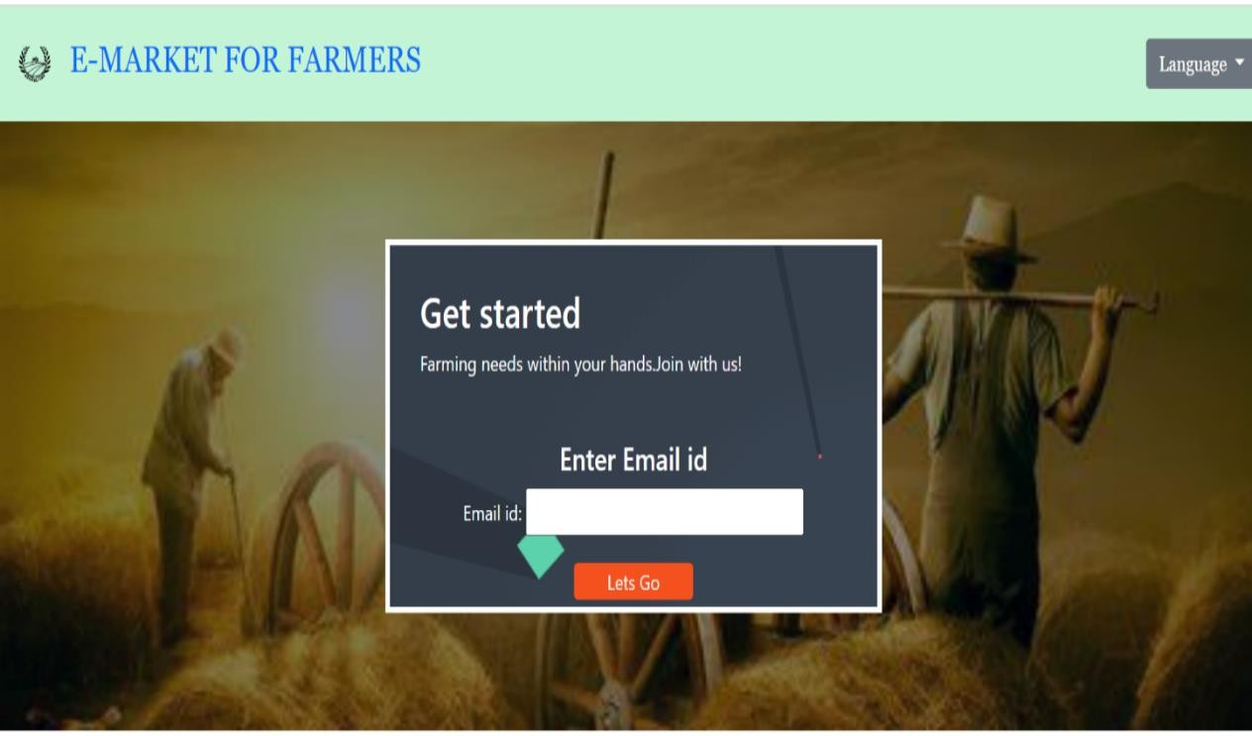

* 1. **VERIFICATION PAGE**



* + - **9.3 PROFILE**

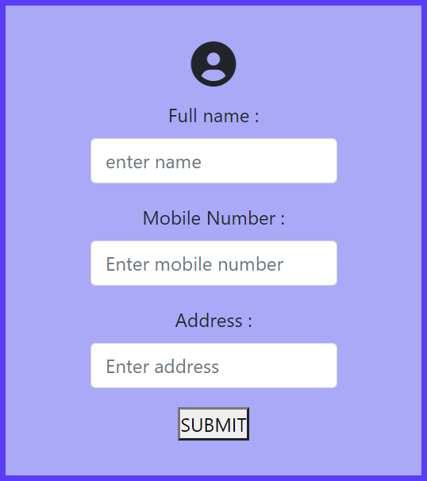

* + - **9.4 HOME PAGE**

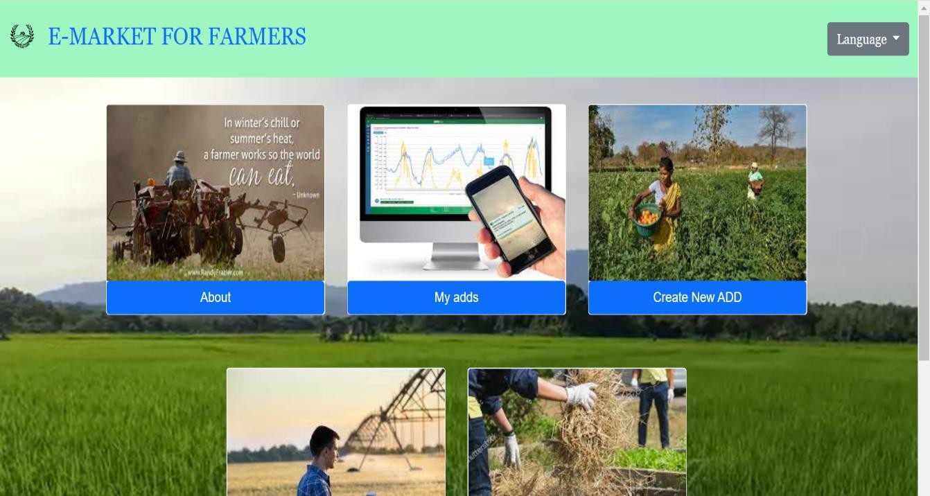

9.5 POST AD

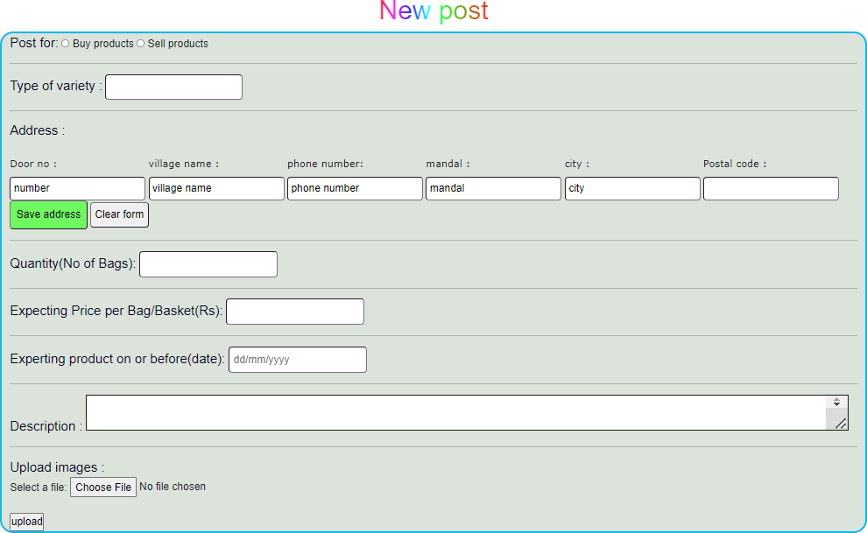

CONCLUSION:-

The concentration of air pollutants in ambient air is governed by the meteorological parameters such as atmospheric wind speed, wind direction, relative humidity, and temperature. Air pollution prediction, is used to measure the predict the quality of the air.

So,it predict the polluted air whether its increasing year by year or decreasing.We are going to use Decision tree and Random forest algorthims in Data mining techniques.To give the acuaracy in data and amount of pollution increasing year by year or decreasing year by year with the analysis made from past few years.